A Christmas Message from our School Ambassadors
Dear Parents/ Carers,
We understand that, as adults, there is a lot of pressure this time of year to create a magical Christmas for your children. We appreciate that you want to provide presents and joyful experiences, and this can mean a lot of stress and worry. However, having had a fantastic meeting with the school’s ambassadors, I wanted to share what they considered to be the most important things about Christmas, which is captured in their message below:
The true magic of Christmas is about spending time with loved ones (family and friends). It’s also about connecting with those you love and experiencing the joy of Christmas spirit - together. What is special is being able to snuggle in at bedtime, play games with your family and stay in your pyjamas all day! Making life-long memories is the most important thing at this time and it is what we will all remember for many years to come.
To celebrate this sentiment and start the Christmas holidays off with a smile, we have two events planned for the last two days of term:
- On Thursday, our fabulous choir will be performing Christmas carols at the school gate during drop off and pick up times.
- Our Well-being Warriors will also be giving out positive handwritten Christmas messages at the end of the day (on the last day of term).
Have a very merry Christmas and enjoy a fun and relaxing break with your children.
Kind Regards
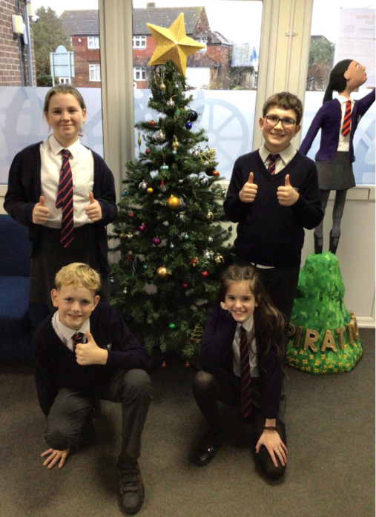
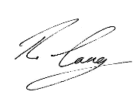
Mr Lang & The School Ambassadors

