Supporting, Speech, Language and Communication (SLC) at St Katherine’s School and Nursery
Speech, language and communication are essential life skills. They are linked to learning, attainment, behaviour, social and emotional development, and mental wellbeing.
The Balanced System® is used in Kent to help everyone work together to support pupils’ speech, language and communication, and this includes us working in a more joined up-way with the speech and language therapy service.
We have an allocated link speech and language therapist from the NHS who we meet with regularly to help us plan and improve our support for speech, language and communication across the school. They also work with individual pupils or groups as needed. Our link therapist is Louise Wallace and your child may see them in class or around school.
Our school is committed to achieving the following outcomes, known as the ‘Five Strands’ of the Balanced System®:
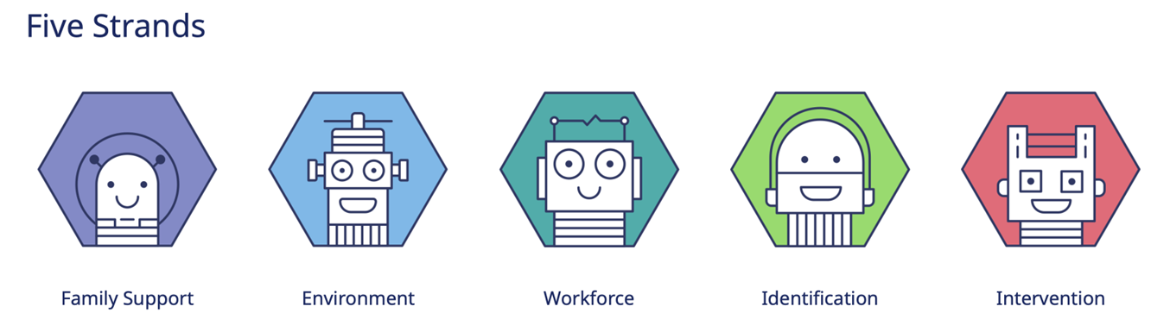
- Family support: Parents have the confidence, knowledge, and skills to support their child's speech, language and communication; and pupils can make pro-active choices about their support.
- Environment: classrooms and other places in school are set up to help pupils to understand and express themselves effectively.
- Workforce development: our staff know how to support pupils with their speech, language and communication.
- Identification: speech, language and communication needs are identified early and effectively.
- Intervention: pupils get the help they need to make progress with their speech, language and communication.
In each strand, there are three levels of support:
- Universal Support: Helps all pupils with speech, language and communication. For example, staff using visual aids to enhance understanding in class.
- Targeted Support: Assists pupils with speech, language and communication needs (SLCN) or those at risk. For example, pre-teaching vocabulary and small language groups.
- Specialist Support: For more complex SLCN requiring individualised approaches. For example, therapy for a child with a complex speech sound disorder.
Pupils may need support at several levels simultaneously, and this can change over time. For instance, specialist support might be helpful at certain points, but pupils will also receive universal and targeted support.
Current focus:
We have been working hard to make sure that we assess the understanding of children who join our school at any stage and working with our youngest children to assess any areas of difficulty. We are aware that many of our children have some form of language or speech difficulty and so as a school focus on oracy across the curriculum.
For more information about the Balanced System® in schools and how speech and language therapy services are working, visit KELSI.
Concerns about your child’s speech, language and communication skills
If you have any concerns about your child’s speech, language or communication skills, please speak to your child’s class teacher first. We will then work together to agree on the next steps.
If necessary, we may discuss your child’s needs with our link therapist and develop a plan. You will be kept informed about any plans to support your child.
An important principle of the Balanced System® is ensuring that what matters most to you and your child is central to agreeing on outcomes and setting targets.
Useful websites for parents (schools to select as appropriate):
Speech, language, and communication needs - Kent County Council (general information about SLCN in Kent including how to access support)
The Pod - KCHFT – (information and resources including workshops delivered by Kent speech and language therapists)
BBC Tiny Happy People (advice and activities for all parents to support speech, language and communication development, up to age 5).
Home - Speech and Language UK: Changing young lives (national charity, lots of information on typical development, resources and advice translated into different languages)
SLCN - Afasic (national charity – information and resources)
RADLD - Raising Awareness of Developmental Language Disorder - RADLD
Parent Portal - Speech and Language Link (information about development and activities to support including for teenagers)
Words for Life | National Literacy Trust | Words for Life (parent advice to support language, literacy and communication for up to 12 years)
Zone In | Words for Life (Tips on boosting reading, writing, speaking and listening skills for young people age 14+)
The Balanced System® in Kent for Speech Language and Communication Needs (SLCN) – KELSI (information aimed at schools and professionals, but may be of interest to parents wanting to understand how the Balanced System works in more detail.

